Lab: Multicurrency Reserving

In this lab, you will create multicurrency reserves following a loss scenario in multiple countries and currencies.

Requirement

You work for a major insurer in the United Kingdom, and one of your clients reports an accident in Italy. The injured pedestrian is treated in Italy, but the damage to the client’s car is superficial, and the car will be driven back to England for repairs. You need to create a claim with a reserve in Euros for injuries, and a reserve in British Pounds for the body work.

Specifications

**2. Create a new Claim for an unverified Commercial Auto Policy.**

1. The Customer is Consolidated Industries of London. The Policy Currency is GBP, as is the Customer’s preferred currency. Make up other details for the Customer as needed.

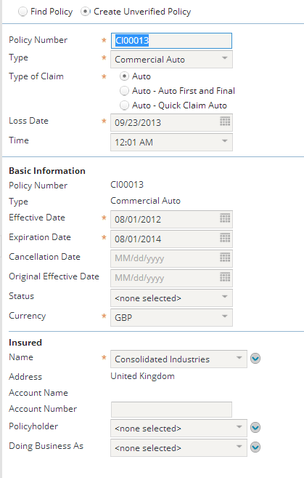

1. The Reporting Person is Pat Penguin, who is the driver of the damaged vehicle and an “employee” of the insured. Again, make up needed details.
2. Accident details: The car hit a pedestrian named Andrea Antonelli who was crossing the Place des Majeurs in Paris. Add exposures for the pedestrian and the car. Make up details as needed.   
   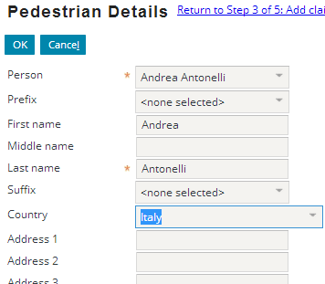
3. Assign the claim to Andy Applegate.

**3) When you are done creating the claim, view it to create reserves and populate other details you may not have populated during the NCW.**

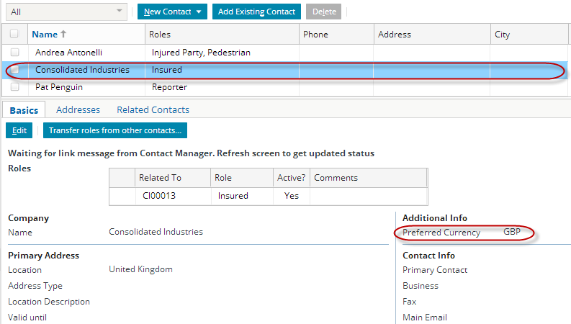  
  
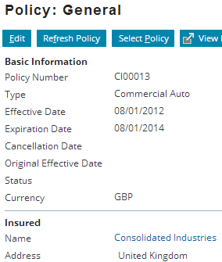  
  
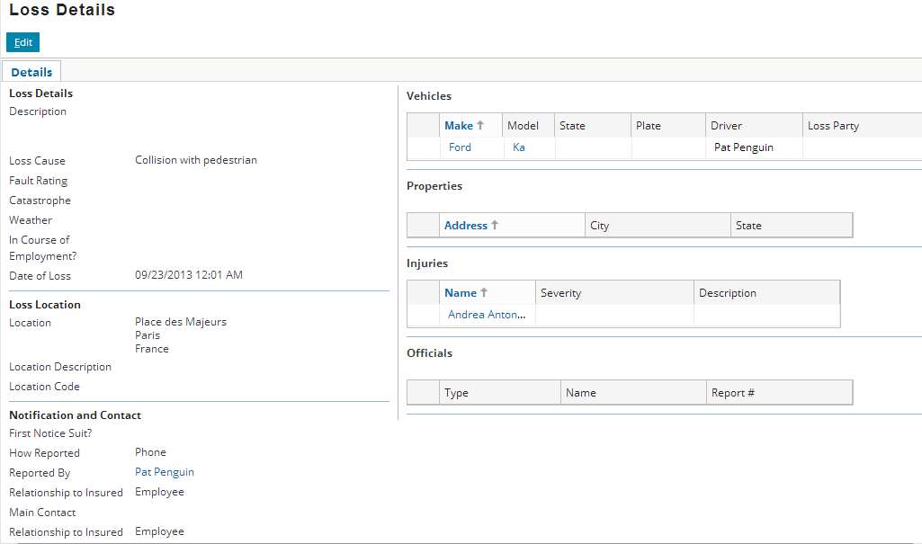

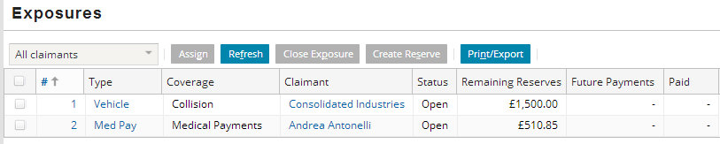

1. Create/set reserves of £1000 for the auto body repair and €750 for the pedestrian’s medical treatment.

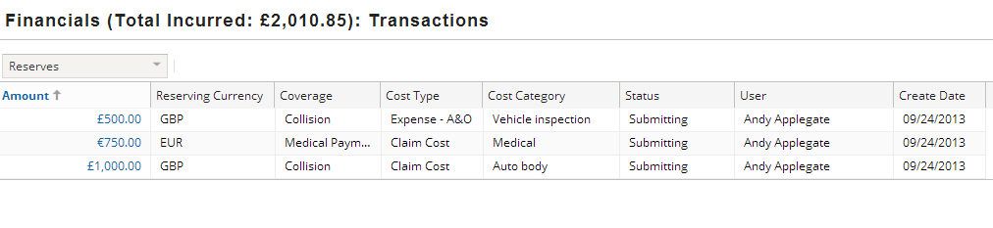

1. Go to the Financials Summary page and view the total for the claim. Then view by reserving currency.  
     
   